**Technical Document of**

**F1 VR Track App & Web**

**Contents**

Annexure I 3

1. Project Overview 3

2. Technologies 4

3. Features and Scope of Work 5

3.1. User Flow of Deliverable 1 5

3.2. User Flow for Deliverable 2 6

3.3. Administrator Web Panel 7

4. Draft Delivery Timeline and Gantt Chart 8

5. Project Management 9

6. Proposed Team of Project 10

7. Assumptions and Constraints 10

7.1. Assumptions 10

7.2. Constraints 10

# Annexure I

# Project Overview

* **Business Need**

The business need is to create a web and app platform for end users using which users will be able to view the whole 3d view of racing track using VR.

* **How the platform would help in achieving the business need**

We are developing an mobile application for end users using which they will be able to view 3D view of tracks and user can roamed around the track using the oculus VR. Along with that users can view the multiple brand overlays.

* **Stakeholders**

|  |  |
| --- | --- |
| **Actor** | **Task** |
| End User | 3D track View  Viewing Brands overlay |
| Admin | Managing Users  Managing content |

* **Project Scope and Development Deliverables**

This project scope comprises of the following components to deliver:

* Design and Development of Mobile Application for End Users (iOS & Android)
* Development of End User Website
* Development and Integration of API
* Development of Admin Web Panel

# Technologies

|  |  |  |
| --- | --- | --- |
| **Development Phases** | | **Tools & Technology** |
| Requirement  Gathering and Analysis | Proposal Drafting, SRS Writing and User Flow Diagram | Microsoft Office Word 2019 / Microsoft Office Presentation 2019 / Microsoft Office Vision 2019 |
| Wire Framing | Axure / UiZard |
| Development | Application | Unity |
| Web Backend | Node.js |
| Website |  |
| Database | MongoDB / MySql |
| Version/s Supported | Android | 9.0 and above |
| iOS | 13.0 and above |
| Browser | Google Chrome, Safari, Mozilla Firefox |
| Quality Assurance  & Testing | Test Cases | MS Office Excel 2019 |
| Testing | Manual |

# Features and Scope of Work

## User Flow of Deliverable 1

* **Splash Screen**
  + User will be able to view the Application Name and Logo on the splash Screen.
* **Home Screen**
  + User will be able to view home screen from where user can access to all the content
    - **View Track (VR View)**
    - **Show Content**
    - **Settings**
* **View Track (in VR)**
  + User will be able to view 3d view of track on the application using this feature.
  + Users will need a oculus VR to view exact 3D model of track.
  + User can move around the track using the application and VR.
  + The Matterport of city will be available in application for users to view with different brand overlays and tracks
  + The application VR view will also show users the city view track.

**Note: A CAD file will be provided to client, using which we will be using to show the above functionality.**

* **Show Content**
  + Users can view details about the track and will be able to access the videos and images of the track shared by admin in that section.
  + A list of videos will be available for users to view which includes the video title and length so users can view content specifically if needed.
* **Settings**
  + **Privacy Policy**
  + **Terms and Condition**
  + **Rate application**
  + **Share application**
  + **Help and Support**

## User Flow of User Website

* **Home Page**
  + User will be able to view the below options on home page
  + **Header Part**
    - **View Track (VR View)**
    - **Show Content**
    - **Settings**
  + **Footer Part**
    - **T & C**
    - **Social Links (If any)**
* **View Track (in VR)**
  + User will be able to view 3d view of track on the Website using this feature.
  + Users will need an oculus VR to view exact 3D model of track.
  + User can move around the track using the application and VR.
  + The Matterport of city will be available on the website for users to view with different brand overlays on tracks and racing flags
  + The Website VR view will also show users the city view track.

**Note: A CAD file will be provided to client, using which we will be using to show the above functionality.**

* **Show Content**

Users can view details about the track and will be able to access the videos and images of the track shared by admin in that section.

A list of videos will be available for users to view which includes the video title and length so users can view content specifically if needed.

* **Settings**
  + **Privacy Policy**
  + **Terms and Condition**
  + **Rate application**
  + **Help and Support**

## Administrator Web Panel

The back end of the platform will be power packed with an administrative panel to manage the updates of data at the application level, website level and as well as back end.

Following would be the key functionalities:

* **Admin Dashboard**
  + Admin will be able to view the content engagement report on the platform.
* **Content Management**
  + Admin will be able to manage the whole content of the website and application.
  + Admin can add/remove/edit the video and image content using this section.
* **General Management**
  + Admin will be to manage the
    - **Terms and Condition**
    - **Privacy Policy**
    - **Help and Support**

# Draft Delivery Timeline and Gantt Chart

|  |  |
| --- | --- |
| **Planned Project Start Date** | **Scheduled Project Completion Date** |
| **Project Duration\*** | 120 |
| 01-Nov-2023 | 05-Sep-2024 |

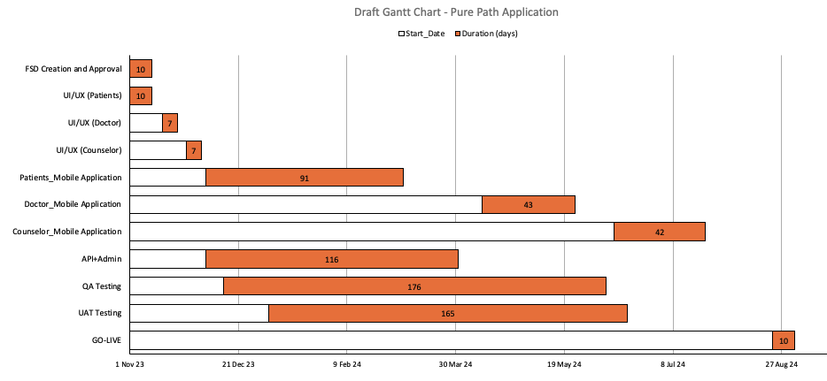

*Project Duration would be met with a condition that the client responses are received   
 on time.

# Project Management

|  |  |  |  |
| --- | --- | --- | --- |
| **Before Project is awarded** | | | |
| **Business Analysis** | **Project Management / Software Development** | **Business Development / Sales** | **Accounting** |
| 1. Project Identify / Analysis 2. Develop one-page proposal overview 3. Create project management overview 4. **<CLIENT NAME>** assigned to business manager GBM   *GBM: Global Business Manager* | 1. Project Evaluation by technical teams 2. Introduction call 1 on 1 interaction with **<CLIENT NAME>** 3. System appropriate services determined 4. Requirements / System application architecting 5. Project needs analysis 6. Detailed proposal development 7. Cost and Time effort estimation | 1. Introduction call 2. Deliverables discussed with **<CLIENT NAME>** 3. Milestones discussed 4. Project success discussed 5. Future growth alignment 6. Detailed proposal provided 7. Payment instructions | 1. Invoice submitted to **<CLIENT NAME>** 2. Payment received 3. Payment confirmation sent to **<CLIENT NAME>** 4. Account forwarded to PM |

|  |  |  |  |
| --- | --- | --- | --- |
| **After Project is awarded** | | | |
| **Phase 1** | **Phase 2** | **Phase 3** | **Phase 4** |
| 1. Project manager assigned 2. Project initiation/ introduction call 3. Online project profile created 4. Weekly project meetings scheduled 5. Reporting formats explained to <CLIENT NAME> | 1. Design, Development / technical teams assigned 2. Project start 3. **<CLIENT NAME>** feedback on weekly 4. Weekly project feedback session- 30 min 5. Reports available on-line 6. Online Rebel catering access of PM system application | 1. Testing / Quality Assurance 2. Live server   testing 3. Final bugs issues fixed 4. Campaign completed | 1. Periodic project maintenance 2. Data backups 3. Web site –System application upgrades 4. On line marketing ** Optional |

# Proposed Team of Project

The proposed team to achieve the deliverables in a time span of 64 Business Weeks   
 comprising of 40 hrs./week is as follows

|  |  |
| --- | --- |
| Designation | Availability |
| Project Manager | Part Time |
| Project Expert | Part Time |
| Designers | Full Time |
| Developers | Full Time |
| Quality Analyst | Full Time |

# Assumptions and Constraints

This section would have the list of all the assumptions that have been considered during the development of proposal accompanied with the list of constraints (i.e., technology restrictions) that would be beyond anyone’s capabilities.

## Assumptions

* All the required CAD files required to develop will be shared and provided by
* Assumption 2

## Constraints

* Constraint 1
* Constraint 2